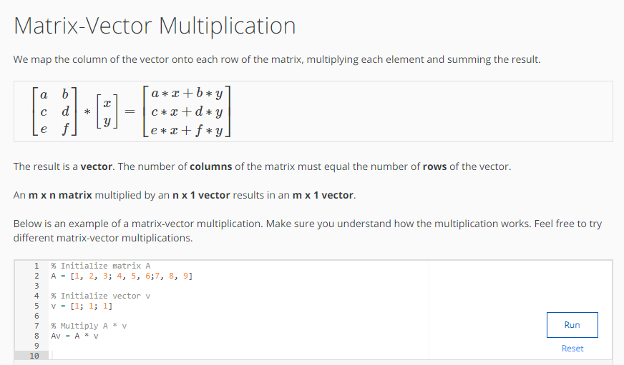

CODE:
% Initialize matrix A
A = [1, 2, 3; 4, 5, 6;7, 8, 9]

% Initialize vector v
v = [1; 1; 1]

% Multiply A * v
Av = A * v

OUTPUT:
